Phase 4 : Development part 2

Customer Churn Prediction

1.Visualizations using IBM Cognos and developing a predictive model

Sactterplot :

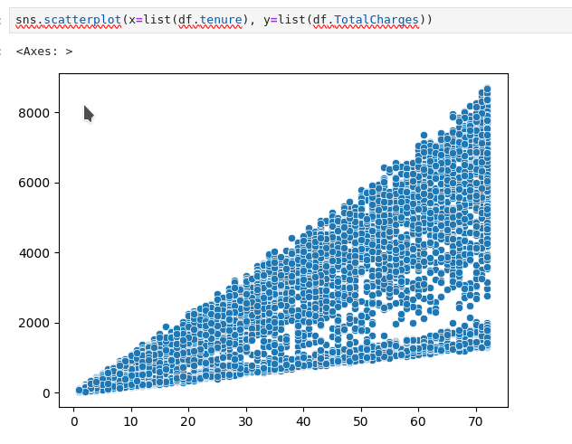

Swarmplot:

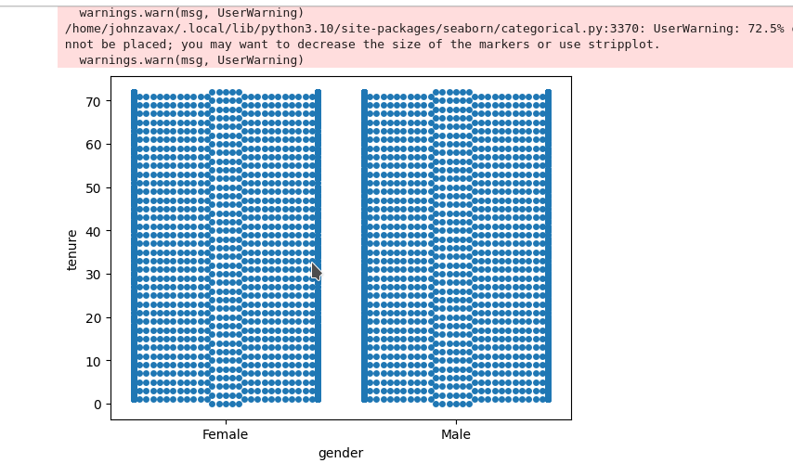

Barplot**:**

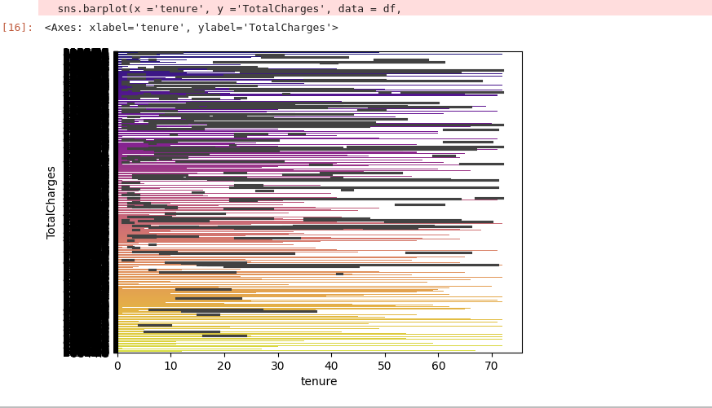

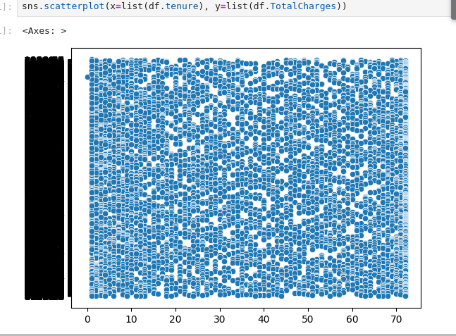

2.Interactive dashboards and reports in IBM Cognos to visualize churn patterns, retention rates, and key factors influencing churn:

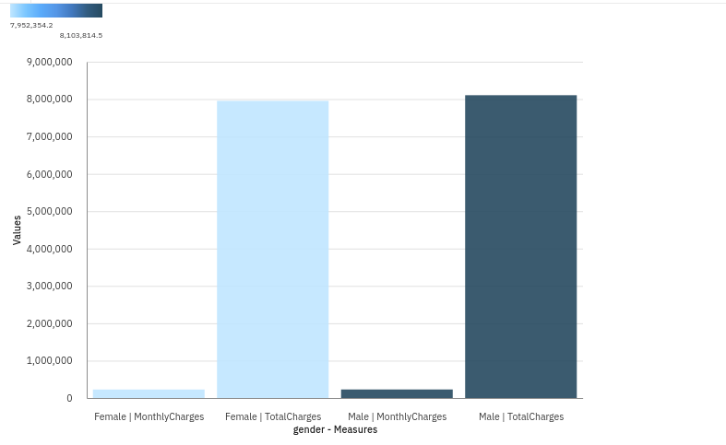

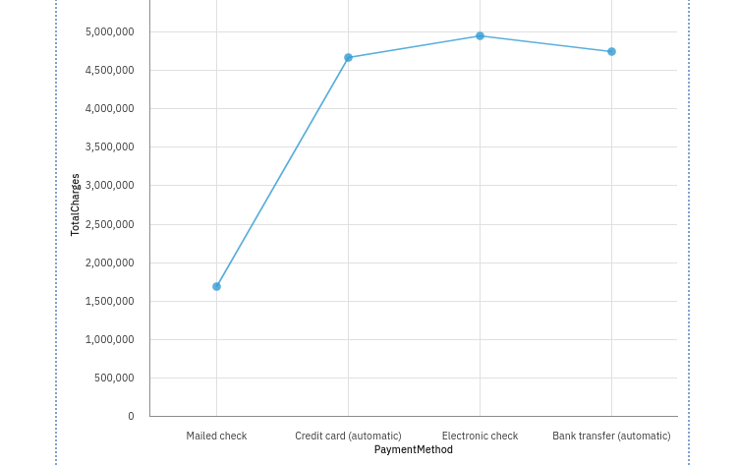

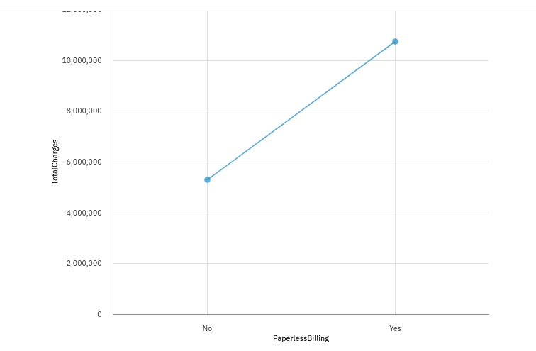

3.machine learning algorithms to build a predictive model that identifies potential churners based on historical data and relevant features

import pandas as pd

import pandas as pd

import numpy as np

import matplotlib.pyplot as plt

import seaborn as sns

cols = ['gender','SeniorCitizen',"Partner","Dependents"]

numerical = cols

plt.figure(figsize=(20,4))

for i, col in enumerate(numerical):

ax = plt.subplot(1, len(numerical), i+1)

sns.countplot(x=str(col), data=df)

ax.set_title(f"{col}")

from sklearn.model_selection import train_test_split

from sklearn.model_selection import train_test_split

from sklearn import preprocessing

from sklearn.datasets import make_classification

from sklearn.preprocessing import binarize, LabelEncoder, MinMaxScaler

# models

from sklearn.linear_model import LogisticRegression

from sklearn.tree import DecisionTreeClassifier

from sklearn.ensemble import RandomForestClassifier, ExtraTreesClassifier

from sklearn import metrics

from sklearn.metrics import accuracy_score, mean_squared_error, precision_recall_curve

from sklearn.model_selection import cross_val_score

#Neural Network

from sklearn.neural_network import MLPClassifier

#Bagging

from sklearn.ensemble import BaggingClassifier, AdaBoostClassifier

from sklearn.neighbors import KNeighborsClassifier

#Naive bayes

from sklearn.naive_bayes import GaussianNB

#Stacking

from mlxtend.classifier import StackingClassifier

finaldf = finaldf.dropna()

finaldf = finaldf.drop(['customerID'],axis=1)

X = finaldf.drop(['Churn'],axis=1)

y = finaldf['Churn']

X_train, X_test, y_train, y_test = train_test_split(X, y, test_size=0.33, random_state=42)

y_train.value_counts()

preds = rf.predict(X_test)

print(accuracy_score(preds,y_test))

Output:

Accuracy_score= **approximately 0.78 on the test dataset.**

